DNS Settings

Step 1: On OFFICE PC-1 Go back to IPv4 settings, set preferred DNS server to 10.16.0.10
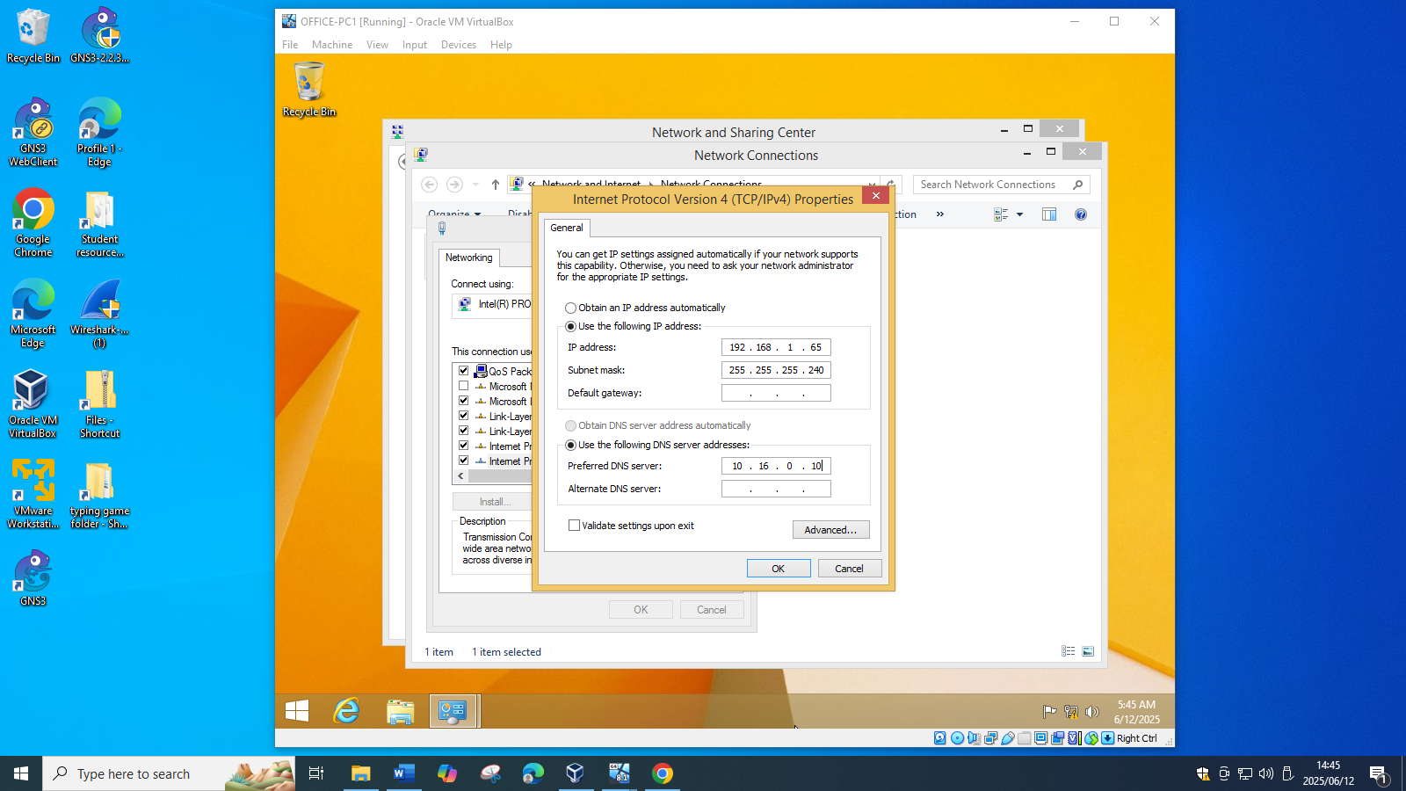
Step 2: On OFFICE PC-2 Go back to IPv4 settings, set preferred DNS server to 10.16.0.10
